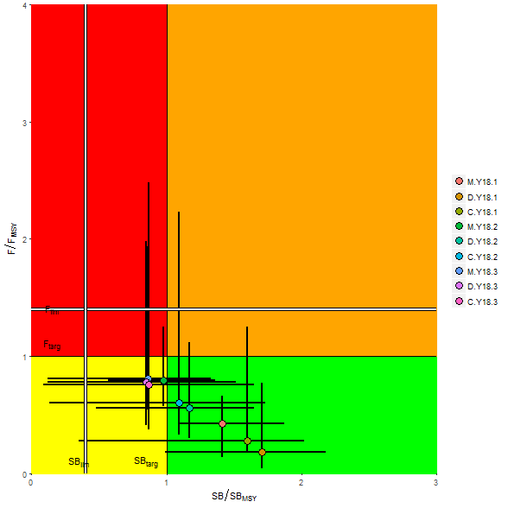

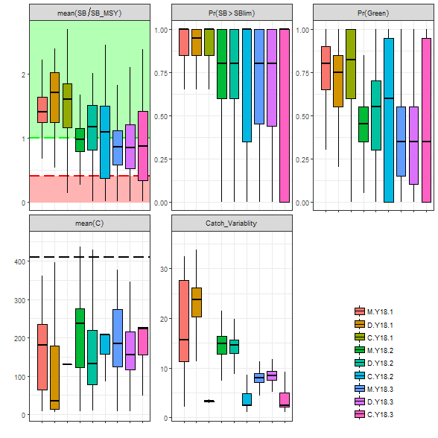

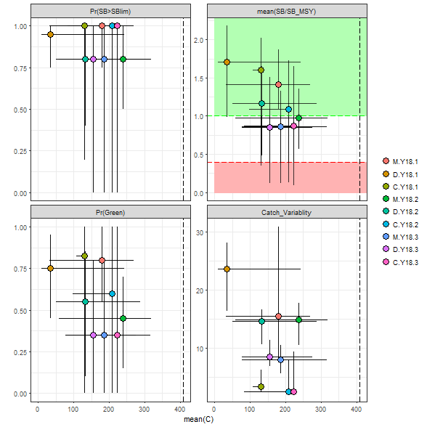

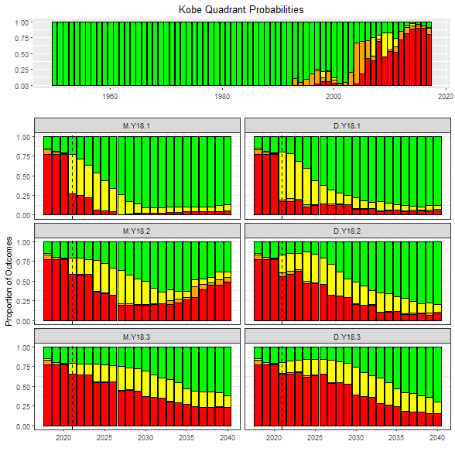

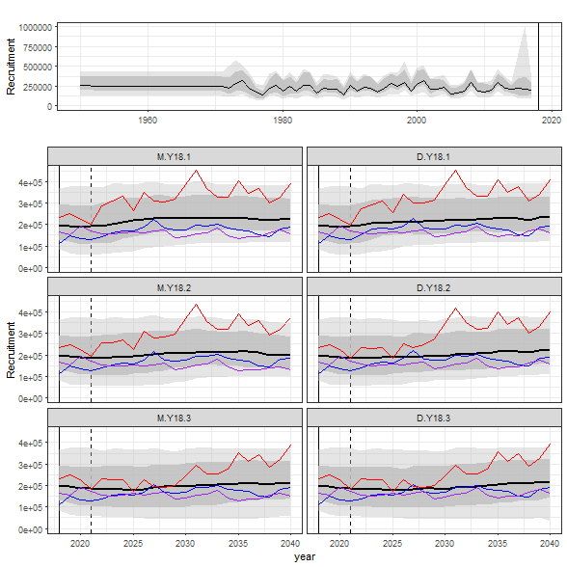

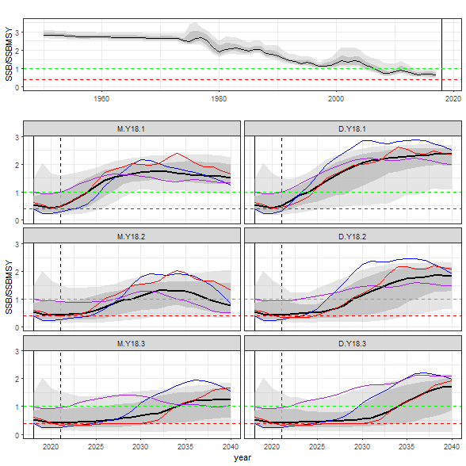

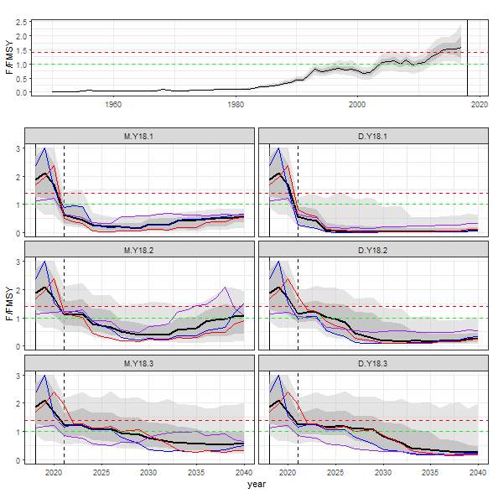

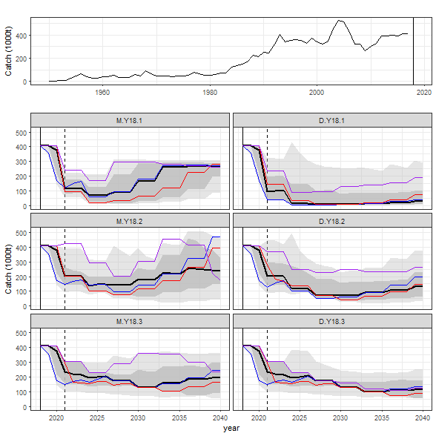

|  |  |  |  |  |  |
| --- | --- | --- | --- | --- | --- |
|  | **Performance Measure** | | | | |
| **Management Procedure** | SB/SBMSY | Prob(Green) | Prob(SB>limit) | Mean Catch | Catch Variability |
| M.Y18.1 | 1.41 (1.25-1.64) | 0.76 | 0.92 | 180.1 (65.3-235.0) | 15.57 |
| D.Y18.1 | 1.71 (1.25-2.02) | 0.71 | 0.91 | 35.0 (14.3-178.8) | 23.71 |
| M.Y18.2 | 0.98 (0.79-1.15) | 0.44 | 0.77 | 238.0 (122.5-276.5) | 14.84 |
| D.Y18.2 | 1.17 (0.81-1.51) | 0.50 | 0.77 | 131.5 (78.4-220.4) | 14.62 |
| M.Y18.3 | 0.86 (0.57-1.12) | 0.39 | 0.69 | 184.9 (125.0-274.8) | 8.04 |
| D.Y18.3 | 0.85 (0.52-1.20) | 0.37 | 0.67 | 155.1 (116.8-215.9) | 8.47 |

|  |  |  |  |  |  |  |  |
| --- | --- | --- | --- | --- | --- | --- | --- |
| **Status : maximise stock status** |  | **1 year average** | | | | | |
|  |  | **M.Y18.1** | **D.Y18.1** | **M.Y18.2** | **D.Y18.2** | **M.Y18.3** | **D.Y18.3** |
| Mean spawner biomass relative to pristine | SB/SB0 | 0.16 | 0.18 | 0.15 | 0.15 | 0.15 | 0.15 |
| Minimum spawner biomass relative to pristine | SB/SB0 | 0.16 | 0.18 | 0.15 | 0.15 | 0.15 | 0.15 |
| Mean spawner biomass relative to SBMSY | SB/SBMSY | 0.47 | 0.51 | 0.43 | 0.44 | 0.42 | 0.42 |
| Mean fishing mortality relative to FMSY | F/Ftar | 0.61 | 0.56 | 1.10 | 1.13 | 1.24 | 1.25 |
| Mean fishing mortality relative to target | F/FMSY | 0.61 | 0.56 | 1.10 | 1.13 | 1.24 | 1.25 |
| Probability of being in Kobe green quadrant | SB,F | 0.24 | 0.22 | 0.21 | 0.17 | 0.22 | 0.21 |
| Probability of being in Kobe red quadrant | SB,F | 0.27 | 0.17 | 0.58 | 0.56 | 0.65 | 0.65 |
| **Safety : maximise the probability of remaining above low stock status (i.e. minimise risk)** | | | | | | | |
| Probability of spawner biomass being above 20% of SB0 | SB | 0.43 | 0.45 | 0.40 | 0.38 | 0.38 | 0.38 |
| Probability of spawner biomass being above BLim | SB | 0.57 | 0.62 | 0.54 | 0.54 | 0.53 | 0.53 |
| **Yield : maximise catches across regions and gears** | | | | | | | |
| Mean catch (1000 t) | C | 113.99 | 97.36 | 204.26 | 204.26 | 235.92 | 235.92 |
| Mean relative CPUE (aggregate) | C | 0.33 | 0.27 | 0.54 | 0.55 | 0.64 | 0.62 |
| Mean catch relative to MSY | C/MSY | 0.58 | 0.61 | 0.53 | 0.54 | 0.53 | 0.53 |
| **Stability: maximise stability in catches to reduce commercial uncertainty** | | | | | | | |
| Mean absolute proportional change in catch | C | 53.22 | 66.22 | 32.84 | 35.27 | 25.00 | 25.00 |
| % Catch coefficient of variation | C | NA | NA | NA | NA | NA | NA |
| Probability of shutdown | C | 0.01 | 0.00 | 0.00 | 0.00 | 0.00 | 0.00 |

|  |  |  |  |  |  |  |  |
| --- | --- | --- | --- | --- | --- | --- | --- |
| **Status : maximise stock status** |  | **5 year average** | | | | | |
|  |  | **M.Y18.1** | **D.Y18.1** | **M.Y18.2** | **D.Y18.2** | **M.Y18.3** | **D.Y18.3** |
| Mean spawner biomass relative to pristine | SB/SB0 | 0.29 | 0.32 | 0.17 | 0.18 | 0.15 | 0.15 |
| Minimum spawner biomass relative to pristine | SB/SB0 | 0.16 | 0.17 | 0.14 | 0.14 | 0.14 | 0.14 |
| Mean spawner biomass relative to SBMSY | SB/SBMSY | 0.85 | 0.88 | 0.51 | 0.51 | 0.44 | 0.44 |
| Mean fishing mortality relative to FMSY | F/Ftar | 0.41 | 0.38 | 0.96 | 1.12 | 1.12 | 1.19 |
| Mean fishing mortality relative to target | F/FMSY | 0.41 | 0.38 | 0.96 | 1.12 | 1.12 | 1.19 |
| Probability of being in Kobe green quadrant | SB,F | 0.41 | 0.38 | 0.25 | 0.17 | 0.23 | 0.18 |
| Probability of being in Kobe red quadrant | SB,F | 0.17 | 0.15 | 0.49 | 0.54 | 0.61 | 0.65 |
| **Safety : maximise the probability of remaining above low stock status (i.e. minimise risk)** | | | | | | | |
| Probability of spawner biomass being above 20% of SB0 | SB | 0.61 | 0.67 | 0.44 | 0.42 | 0.39 | 0.38 |
| Probability of spawner biomass being above BLim | SB | 0.72 | 0.78 | 0.58 | 0.60 | 0.54 | 0.54 |
| **Yield : maximise catches across regions and gears** | | | | | | | |
| Mean catch (1000 t) | C | 112.73 | 68.31 | 168.53 | 163.58 | 214.96 | 215.51 |
| Mean relative CPUE (aggregate) | C | 0.33 | 0.19 | 0.50 | 0.46 | 0.59 | 0.59 |
| Mean catch relative to MSY | C/MSY | 0.94 | 1.05 | 0.57 | 0.61 | 0.53 | 0.53 |
| **Stability: maximise stability in catches to reduce commercial uncertainty** | | | | | | | |
| Mean absolute proportional change in catch | C | 22.40 | 31.00 | 15.65 | 16.92 | 10.00 | 10.00 |
| % Catch coefficient of variation | C | 0.36 | 0.74 | 0.21 | 0.20 | 0.12 | 0.12 |
| Probability of shutdown | C | 0.11 | 0.25 | 0.01 | 0.00 | 0.01 | 0.01 |

|  |  |  |  |  |  |  |  |
| --- | --- | --- | --- | --- | --- | --- | --- |
| **Status : maximise stock status** |  | **10 year average** | | | | | |
|  |  | **M.Y18.1** | **D.Y18.1** | **M.Y18.2** | **D.Y18.2** | **M.Y18.3** | **D.Y18.3** |
| Mean spawner biomass relative to pristine | SB/SB0 | 0.44 | 0.45 | 0.28 | 0.25 | 0.19 | 0.19 |
| Minimum spawner biomass relative to pristine | SB/SB0 | 0.16 | 0.15 | 0.13 | 0.12 | 0.13 | 0.13 |
| Mean spawner biomass relative to SBMSY | SB/SBMSY | 1.27 | 1.26 | 0.79 | 0.71 | 0.55 | 0.54 |
| Mean fishing mortality relative to FMSY | F/Ftar | 0.37 | 0.23 | 0.75 | 0.83 | 0.98 | 1.10 |
| Mean fishing mortality relative to target | F/FMSY | 0.37 | 0.23 | 0.75 | 0.83 | 0.98 | 1.10 |
| Probability of being in Kobe green quadrant | SB,F | 0.62 | 0.56 | 0.35 | 0.28 | 0.26 | 0.20 |
| Probability of being in Kobe red quadrant | SB,F | 0.10 | 0.14 | 0.35 | 0.43 | 0.53 | 0.59 |
| **Safety : maximise the probability of remaining above low stock status (i.e. minimise risk)** | | | | | | | |
| Probability of spawner biomass being above 20% of SB0 | SB | 0.77 | 0.77 | 0.56 | 0.51 | 0.44 | 0.41 |
| Probability of spawner biomass being above BLim | SB | 0.84 | 0.85 | 0.68 | 0.65 | 0.59 | 0.57 |
| **Yield : maximise catches across regions and gears** | | | | | | | |
| Mean catch (1000 t) | C | 107.86 | 39.81 | 160.79 | 124.45 | 194.61 | 193.41 |
| Mean relative CPUE (aggregate) | C | 0.32 | 0.11 | 0.44 | 0.34 | 0.54 | 0.53 |
| Mean catch relative to MSY | C/MSY | 1.40 | 1.56 | 0.89 | 0.94 | 0.64 | 0.63 |
| **Stability: maximise stability in catches to reduce commercial uncertainty** | | | | | | | |
| Mean absolute proportional change in catch | C | 25.68 | 25.65 | 16.06 | 15.94 | 9.95 | 10.00 |
| % Catch coefficient of variation | C | 0.45 | 1.10 | 0.30 | 0.40 | 0.15 | 0.18 |
| Probability of shutdown | C | 0.22 | 0.45 | 0.03 | 0.03 | 0.03 | 0.03 |

|  |  |  |  |  |  |  |  |
| --- | --- | --- | --- | --- | --- | --- | --- |
| **Status : maximise stock status** |  | **20 year average** | | | | | |
|  |  | **M.Y18.1** | **D.Y18.1** | **M.Y18.2** | **D.Y18.2** | **M.Y18.3** | **D.Y18.3** |
| Mean spawner biomass relative to pristine | SB/SB0 | 0.50 | 0.59 | 0.35 | 0.40 | 0.30 | 0.30 |
| Minimum spawner biomass relative to pristine | SB/SB0 | 0.16 | 0.13 | 0.12 | 0.12 | 0.12 | 0.12 |
| Mean spawner biomass relative to SBMSY | SB/SBMSY | 1.41 | 1.71 | 0.98 | 1.17 | 0.86 | 0.85 |
| Mean fishing mortality relative to FMSY | F/Ftar | 0.42 | 0.18 | 0.79 | 0.56 | 0.80 | 0.78 |
| Mean fishing mortality relative to target | F/FMSY | 0.42 | 0.18 | 0.79 | 0.56 | 0.80 | 0.78 |
| Probability of being in Kobe green quadrant | SB,F | 0.76 | 0.71 | 0.44 | 0.50 | 0.39 | 0.37 |
| Probability of being in Kobe red quadrant | SB,F | 0.07 | 0.10 | 0.34 | 0.27 | 0.40 | 0.41 |
| **Safety : maximise the probability of remaining above low stock status (i.e. minimise risk)** | | | | | | | |
| Probability of spawner biomass being above 20% of SB0 | SB | 0.87 | 0.85 | 0.66 | 0.67 | 0.57 | 0.55 |
| Probability of spawner biomass being above BLim | SB | 0.92 | 0.91 | 0.77 | 0.77 | 0.69 | 0.67 |
| **Yield : maximise catches across regions and gears** | | | | | | | |
| Mean catch (1000 t) | C | 180.12 | 35.02 | 237.98 | 131.51 | 184.94 | 155.10 |
| Mean relative CPUE (aggregate) | C | 0.51 | 0.10 | 0.64 | 0.36 | 0.52 | 0.43 |
| Mean catch relative to MSY | C/MSY | 1.72 | 2.07 | 1.21 | 1.45 | 1.08 | 1.19 |
| **Stability: maximise stability in catches to reduce commercial uncertainty** | | | | | | | |
| Mean absolute proportional change in catch | C | 15.57 | 23.71 | 14.84 | 14.62 | 8.04 | 8.47 |
| % Catch coefficient of variation | C | 0.48 | 0.94 | 0.48 | 0.49 | 0.22 | 0.30 |
| Probability of shutdown | C | 0.18 | 0.54 | 0.06 | 0.10 | 0.06 | 0.06 |